
VIETNAM NATIONAL UNIVERSITY, HANOI
INTERNATIONAL SCHOOL



REPORT OF FINAL EXAM PROJECT
Topic: Green house light,temperature and humidity management system

Subject: Simulation of digital circuit
Class: INS313501
Lecturer: PhD. Pham Ngoc Thanh

Group 8

Student’s name | Student’s ID
Doan Duy Long | 22070843
Pham Tan Minh | 22070977
Nguyen Tran Hai Phong | 22070701

Hanoi, 12/2025
TABLE OF CONTENT

PROJECT INFORMATION 6
LIST OF ABBREVIATIONS 8
ABSTRACT 10
EXECUTIVE SUMMARY 11
CHAPTER 1. OVERVIEW AND PROJECT PROPOSAL 13
1.1 Introduction 13
1.2 Social Factors Analysis 13
1.2.1 Climate Change and Environmental Instability 13
1.2.2 Food Security and Sustainable Agriculture 14
1.2.3 Demand for High-Tech Agriculture Solutions 14
1.3 Project Objectives 15
1.4 Project Scope and Stakeholders 15
1.4.1 Project Scope 15
1.4.2 Stakeholders 16
1.5 Project Plan and Milestones 16
1.6 Cost Estimation and Budget Planning 16
1.6.1 Financial Overview: 16
1.6.2 Market Volatility Disclaimer: 17
1.6.3 Bill of Materials (BOM) The estimated budget is detailed in the table below: 17
1.6.4 Economic Feasibility Analysis : 19
1.7 Chapter Summary 19
CHAPTER 2. LITERATURE REVIEW AND SYSTEM OVERVIEW 20
2.1 Introduction 20
2.2 Overview of Smart Greenhouse Control Systems 20
2.3 Review of Related Projects 21
2.3.1 Project A – Smart Greenhouse Based on Arduino Uno (Monitor/Control Temp, Soil, Light) 21
2.3.2 Project B – IoT Smart Greenhouse for Orchids (IoT + Cloud Monitoring) 22
2.3.3 Project C – Arduino-based System with Pest Detection (Automation + PIR) 22
2.3.4 Comparative Table: Related Works vs OUR Project 23
2.3.5 Comparative Insight & Project Novelty 24
2.3.5 What Make Our Project Stand Out 24
2.3.6 Conclusion 25
2.4 Limitations of Existing Studies 25
2.5 Proposed System Architecture 26
2.5.1 Overall Block Diagram Description 26
2.5.2 Functional Subsystem Division 26
Subsystem 1: Weather and Roof Control 26
Subsystem 2: Temperature and Humidity Regulation 26
Subsystem 3: Soil Moisture and Irrigation Control 27
2.5.3 Design Rationale 27
2.6 Chapter Summary 27
CHAPTER 3. TECHNICAL DESIGN 28
3.1 Introduction 28
3.2 Overall System Block Diagram 28
3.3 Hardware Design 30
3.3.1 System Architecture 30
3.3.2 Circuit Overview 30
3.3.3 Explain the motor circuit 31
3.3.4 Explain the LCD control circuit 33
3.3.5 Explanation of circuit for climate and irrigation regulation 34
3.3.6 Explanation of circuit for Rain Detection, Light Monitoring, and Curtain Control 37
3.4 Component Selection 40
3.4.1 Microcontroller Unit (MCU) 41
3.4.2 Temperature and Humidity Sensor 41
3.4.3 Soil Moisture Sensor 42
3.4.4 Light Intensity Sensor 42
3.4.5 Rain Sensor 43
3.4.6 Actuators 43
3.4.6 Display and User Interface 44
3.4.7 Power Consumption Analysis and Power Supply Selection 44
A. Control Logic Unit (5V DC) 45
B. DC Actuation Unit (24V DC) 45
C. AC Heating Unit (220V AC) 46
3.4.8 Summary of Component Selection 47
3.5 Software & Algorithm Design 47
3.5.1 Functional Blocks 47
3.5.2 Control Logic Principles 47
3.6 Flowchart & Pseudocode 48
3.6.1 Overall Flowchart 48
3.6.2 Pseudocode Example 48
3.7 Reliability & Safety Measures 49
3.8 Summary 49
CHAPTER 4. SIMULATION & EVALUATION 50
4.1 Introduction 50
4.2 Simulation Environment 50
4.2.1 Implementation Tools 50
4.2.2 Simulated Hardware Configuration 50
4.3. Simulation Scenarios 51
4.3.1. Scenario 1: Temperature Control (Heat/Cold Stress) 51
4.3.2. Scenario 2: Rain Response (Priority Logic) 53
4.3.3. Scenario 3: Light-Based Curtain Control (Auto Mode) 55
4.3.4. Scenario 4: Automated Irrigation System 57
4.3.5. Scenario 5: Blown Fuse Indicator Test (Fault Condition) 58
4.4. Result Analysis 59
4.4.1. Functional Assessment 59
4.4.2 Simulation Results Summary Table 60
4.5 Feasibility for Real Implementation 60
4.6 Chapter Summary 61
CHAPTER 5. CONCLUSION AND FUTURE WORK 62
5.1 Conclusion 62
5.2 Engineering Significance 62
5.3 Limitations 63
5.4 Future Work 63
5.5 Final Remarks 64
APPENDIX 65
A. Source Code — Arduino 65
B. Proteus Schematic Description 71
B.1 Overview 71
B.2 Key Signal Flows 72
REFERENCES 73

TABLE OF FIGURE
Figure 1: Overall Functional Block Diagram of the Smart Greenhouse System 30
Figure 2: Motor Circuit 32
Figure 3: Circuit for climate and irrigation regulation 35
Figure 4:Circuit for Rain Detection, Light Monitoring, and Curtain Control 38
Figure 5: Flowchart 49
Figure 6: LCD Case 1 – Scen1 53
Figure 7: Fan system 53
Figure 8: LCD Case 2 – Scen1 54
Figure 9: Lamp system 54
Figure 10: Servo system closes curtain when rain 55
Figure 11: LCD Scen2 55
Figure 12: LCD Scen3 - 1 56
Figure 13: Servo system opens curtain when sunny 57
Figure 14: LCD Scen 3 - 2 57
Figure 15: Servo system closes curtain when dark 58
Figure 16: Pump 58
Figure 17: LCD Scen4 59
Figure 18: Fan system when error 60
Figure 19: Overall circuit simulation in Proteus 72

PROJECT INFORMATION
Title: “Greenhouse light, temperature and humidity management system”
- Kind of project: Engineering Project
- Team members:
Đoàn Duy Long: 22070843 (Leader)
Phạm Tân Minh: 22070977
Nguyễn Trần Hải Phong: 22070701
- Contribute:
Members | Theoretical development | Circuit development | Circuit analysis | Slide | Final report
Đoàn Duy Long  (Leader) | System Architecture Design  Relay Driver Selection | Fan control circuit (24V)  Relay & Isolation Circuit  LCD I2C Hardware Interface | Simulation: Cooling System (Fan Logic) System Integration | Content Outline  Technical Review | Result Analysis Final Review  Chapter 4
Nguyễn Trần Hải Phong | Cost Estimation  Component Sourcing | Heating system circuit(220V)  LCD Display Logic (Layout & Text)  Soil Moisture Circuit | Simulation: Heating Logic  LCD Display Testing | Presentation Script  Visuals & Diagrams | Chapter 1, 2  Abstract
Phạm Tân Minh | Literature Review  Requirement Analysis | Rain Sensor Integration  Servo Motor Control (Curtains)  Priority Logic Design | Simulation: Rain & Curtain Response  Servo Smoothness Test | Slide Design  Formatting | Chapter 3, 5  Appendix

LIST OF ABBREVIATIONS
Abbreviation | Full Term
ADC | Analog-to-Digital Converter
API | Application Programming Interface
BOM | Bill of Materials
DC | Direct Current
DHT | Digital Humidity and Temperature Sensor
EMF | Electromotive Force
GDP | Gross Domestic Product
GUI | Graphical User Interface
HEX | Hexadecimal File
IDE | Integrated Development Environment
I2C | Inter-Integrated Circuit
IoT | Internet of Things
LCD | Liquid Crystal Display
LDR | Light Dependent Resistor
LED | Light Emitting Diode
MCU | Microcontroller Unit
PCB | Printed Circuit Board
PWM | Pulse Width Modulation
RH | Relative Humidity
VAC | Volt Alternating Current
VDC | Volt Direct Current

ABSTRACT
The rapid development of modern agriculture has created an increasing demand for automated and intelligent greenhouse systems capable of maintaining optimal environmental conditions while minimizing human intervention. This project presents the design and simulation of a smart greenhouse control system using Arduino, focusing on environmental monitoring and automated control of key greenhouse parameters.
The proposed system integrates multiple sensors, including temperature and humidity, light intensity, rainfall, and soil moisture sensors, to continuously monitor environmental conditions inside the greenhouse. Based on sensor feedback, the Arduino microcontroller executes a threshold-based control algorithm to regulate various actuators such as ventilation fans, heating lamps, irrigation pumps, and curtain control servos. Priority-based logic is implemented to ensure system safety and energy efficiency, particularly under adverse weather conditions.
The entire system was designed and validated using Proteus simulation software, allowing for comprehensive testing under different environmental scenarios without physical hardware implementation. Simulation results demonstrate that the system responds accurately to sensor inputs and performs reliable automatic control in accordance with the proposed design specifications.
This study confirms that the proposed smart greenhouse system is technically feasible, cost-effective, and suitable for further development toward real-world deployment. The system provides a scalable foundation for future enhancements, including Internet of Things (IoT) integration, advanced control algorithms, and real-time data analytics.
Keywords: Smart greenhouse, Arduino, environmental monitoring, automation, Proteus simulation.

EXECUTIVE SUMMARY
Modern agriculture faces significant challenges due to climate variability, labor shortages, and the increasing demand for sustainable food production. Greenhouse cultivation offers a controlled environment for crop growth; however, traditional greenhouse management often relies heavily on manual monitoring and operation, leading to inefficiencies and increased operational costs.
This project proposes a smart greenhouse control system based on Arduino, designed to automate environmental monitoring and control processes in a greenhouse setting. The system combines multiple environmental sensors with actuator-based control to maintain optimal growing conditions for crops. Key monitored parameters include temperature, humidity, ambient light intensity, rainfall, and soil moisture.
The system architecture is organized into three functional subsystems:
- Weather and Curtain Control Subsystem, utilizing rain and light sensors in conjunction with servo motors to protect crops from harsh weather conditions.
- Climate Control Subsystem, which regulates temperature and humidity using ventilation fans and heating lamps based on real-time sensor feedback.
- Irrigation Control Subsystem, which automates water supply using soil moisture sensing to prevent under- or over-irrigation.
A threshold-based control strategy was selected for its simplicity, reliability, and compatibility with low-cost embedded platforms. System behavior was validated through detailed simulation using Proteus, where multiple operating scenarios were tested to verify correct sensor detection, logical decision-making, and actuator response.
Simulation results indicate that the proposed system operates reliably and in accordance with its design objectives. The modular architecture allows for easy scalability and future upgrades, including wireless communication, cloud-based monitoring, and intelligent control algorithms.
Overall, this project demonstrates a practical and cost-effective solution for smart greenhouse automation and serves as a strong technical foundation for future research, development, and real-world implementation.

CHAPTER 1. OVERVIEW AND PROJECT PROPOSAL

1.1 Introduction
Agriculture remains a key economic sector in Vietnam, making a significant contribution to food security, employment, and the livelihoods of millions of farmers. However, agricultural production is increasingly negatively impacted by climate change and environmental instability. In many localities, phenomena such as prolonged heatwaves, unusually heavy rainfall, sudden temperature changes, and droughts are occurring with increasing frequency and severity, leading to reduced crop yields, increased care costs, and the risk of crop failure.
In this context, traditional outdoor farming methods, which are heavily dependent on natural conditions, are gradually revealing limitations in their ability to control the growing environment. Therefore, technological solutions, such as smart greenhouse systems integrated with sensors and automatic controls, are considered an important direction to optimize growing conditions, reduce risks, and improve production efficiency.

1.2 Social Factors Analysis

1.2.1 Climate Change and Environmental Instability
Climate change is not just a subjective perception but is also reflected in scientific data. An in-depth report on climate change and development shows that damage from climate instability could cause Vietnam's agricultural output to decrease by about 5.6–6.2% by 2030 and 7.6–10.6% by 2050 if no effective response measures are taken [1] . These changes occur nationwide, from the plains to the mountainous and coastal areas.
Different adverse climate conditions appear depending on the region. In the North, seasonal temperature differences and erratic cold-hot waves can affect winter vegetable crops. The Central region frequently faces droughts interspersed with storms and floods, causing damage to crops and arable land. In lowland areas, saltwater intrusion and flooding are major risk factors, especially when sea level rises [2]
These environmental changes create a stressful environment for crops, increasing the risk of malnutrition, pests and diseases, and reducing the quality of agricultural products, forcing growers to face higher risks in production.

1.2.2 Food Security and Sustainable Agriculture
Climate change is a direct threat to food security. Agriculture accounts for a large proportion of the rural economic structure and contributes significantly to the gross domestic product (GDP). Therefore, reduced crop yields can cause negative economic and social consequences. According to domestic statistics, economic losses caused by natural disasters and climate change can amount to trillions of VND each year, mainly due to crop failure, property damage and production recovery costs [3].
In particular, leafy vegetables and short-term crops are very sensitive to environmental conditions. Unstable fluctuations in temperature, humidity, and rainfall can reduce productivity and product quality, while also increasing costs due to pest control or inefficient irrigation. Some localities have recorded crop failures or significant yield reductions in recent years due to unusual weather patterns.
Therefore, sustainable agricultural solutions are needed to reduce risks, optimize resources, and support farmers in ensuring the quantity and quality of agricultural products.

1.2.3 Demand for High-Tech Agriculture Solutions
Given the above challenges, the demand for high-tech applications in agriculture is increasing. Manual inspection and irrigation are not only time-consuming and labor-intensive but also heavily reliant on individual experience, easily leading to errors in crop care.
Smart greenhouse systems with their closed structure and automatic control capabilities effectively address these issues. Instead of relying entirely on weather and human intervention, the system uses environmental sensors to continuously collect data and control devices such as water pumps, ventilation fans, blinds, and lighting in real time, helping to maintain a stable and optimal environment for crops.
The application of technological solutions not only reduces labor burdens but also improves productivity, quality, and sustainability in agricultural production.

1.3 Project Objectives
The main objective of the project is to design and simulate a smart greenhouse system. Specific objectives include:
- Monitoring important environmental parameters such as temperature, air humidity, light, rainfall, and soil moisture using appropriate sensors.
- Automatically controlling irrigation, ventilation, blinds, and lighting systems to maintain optimal growing conditions for crops.
- Simulate different environmental scenarios in Proteus software to test and evaluate system performance.
- Propose a model that can be practically implemented on a small scale with reasonable cost and high scalability.

1.4 Project Scope and Stakeholders

1.4.1 Project Scope
The scope of the project focuses on researching, designing, simulating, and evaluating the performance of a smart greenhouse system for growing vegetables and short-term crops. The scope of this project includes:
- Hardware design of sensor and actuator circuits
- Control logic development and algorithm design
- Software implementation using Arduino
- Simulation and functional validation using Proteus
The project does not include:
- Large-scale greenhouse structural design
- Internet-based data transmission or cloud analytics
- Long-term field testing with real crops

1.4.2 Stakeholders
The main stakeholders of this project include:
- Small and medium-scale vegetable and crop farmers.
- Students and faculty in the fields of engineering and agriculture.
- Researchers interested in the application of automation and IoT in agriculture.
- Educational and training organizations in the field of control engineering and embedded systems.

1.5 Project Plan and Milestones
The project is organized into clearly defined phases to ensure systematic development and evaluation.
Phase | Description | Estimated Duration
1 | Requirement analysis and literature review | 7 days
2 | System architecture and block diagram design | 7 days
3 | Hardware design and component selection | 5 days
4 | Software development and algorithm design | 7 days
5 | Simulation setup and testing (Proteus) | 7 days
6 | Result analysis and report completion | 10 days

1.6 Cost Estimation and Budget Planning

1.6.1 Financial Overview:
A preliminary cost estimation is essential to evaluate the economic feasibility of the proposed Greenhouse Management System. The budget is designed to minimize costs while ensuring technical reliability for a prototype-level implementation.

1.6.2 Market Volatility Disclaimer:
Please note that the prices listed below are based on average market rates 12 / 2025 . Component costs are subject to fluctuation depending on supplier availability, shipping fees, and market changes at the time of actual procurement.

1.6.3 Bill of Materials (BOM) The estimated budget is detailed in the table below:

Category | Component | Quantity | Unit Price (VND) | Total (VND)
Control | Arduino Uno | 1 | 83,800 | 83,800
 | LCD2004A I2C | 1 | 80,000 | 80,000
Sensors | DHT11 Sensor | 1 | 18,700 | 18,700
 | Rain Sensor Module | 1 | 18,000 | 18,000
 | LDR Sensor | 1 | 11,500 | 11,500
 | Soil Moisture Sensor | 1 | 17,000 | 17,000
Actuators | Servo Motors | 2 | 237,000 | 474,000
 | Relay | 3 | 25,000 | 75,000
 | Water Pump | 1 | 285,000 | 285,000
 | Heater + Light Socket | 4 | 50,000 | 200,000
 | Fan | 5 | 217,000 | 1,085,000
Misc. | Power Supply (220V-24V) | 1 | 450,000 | 450,000
 | Fuse / Fuse Holder | 6 | 16,667 | 100,000
 | Resistors | 7 | 1,714 | 12,000
 | Led | 7 | 1,429 | 10,000
Subtotal |  |  |  | 2,920,000
Contingency | Risk buffer (approx. 10% of Sub-total) |  |  | 292,000
GRAND TOTAL |  |  |  | 3,212,000 VND

1.6.4 Economic Feasibility Analysis :
The total estimated cost for the prototype is approximately 3.2 million VND. This budget is considered economically viable for small-scale agricultural applications and educational purposes.
- Cost Efficiency: By using widely available components (Arduino, standard sensors), the maintenance and replacement costs remain low.
- Scalability: The system design allows for upgrading directly to industrial sensors without changing the core architecture, optimizing future investment.

1.7 Chapter Summary
This chapter has presented the motivation, objectives, scope, and feasibility of the proposed smart greenhouse control system. By addressing real-world agricultural challenges through engineering design and automation, the project establishes a strong foundation for further technical development. The following chapters will focus on theoretical background, system architecture, detailed technical design, and simulation-based validation.

CHAPTER 2. LITERATURE REVIEW AND SYSTEM OVERVIEW

2.1 Introduction
The rapid development of embedded systems and low-cost microcontrollers has significantly accelerated the adoption of automation technologies in modern agriculture. Among these applications, smart greenhouse systems have emerged as an effective solution to mitigate environmental uncertainties and improve crop productivity.
This chapter presents a literature review of existing smart greenhouse control systems, focusing on Arduino-based and sensor-driven architectures. Based on this review, the chapter then introduces the overall system architecture proposed in this project, highlighting its structure, operating principles, and improvements over previous works.

2.2 Overview of Smart Greenhouse Control Systems
A greenhouse is an enclosed environment designed to provide optimal growing conditions for plants by controlling key environmental parameters such as temperature, humidity, light intensity, and soil moisture. Traditional greenhouses rely heavily on manual monitoring and control, which is labor-intensive and prone to human error.
Recent studies have demonstrated that automated greenhouse control systems can significantly enhance crop yield, reduce water and energy consumption, and ensure consistent environmental conditions. These systems typically consist of:
- Environmental sensors (temperature, humidity, light, soil moisture)
- A processing unit (microcontroller or embedded system)
- Actuators (fans, pumps, heaters, lighting systems)
- A control algorithm that links sensor data to actuator responses

2.3 Review of Related Projects
Below are three representative smart greenhouse projects from published sources (journals/conferences/online), followed by a comparative discussion highlighting both strengths and weaknesses.

2.3.1 Project A – Smart Greenhouse Based on Arduino Uno (Monitor/Control Temp, Soil, Light)
This research describes a smart greenhouse using Arduino Uno, DHT22 (temp/humidity), YL-69 (soil moisture), and TEMT6000 (light) sensors. It uses three actuators and a GSM module for remote monitoring [4].
Key Features
- Multiple sensors for environment monitoring
- GSM communication module for remote updates
- Focus on efficiency, durability, and aesthetics validated by experts
Advantages
- Combines several environmental factors (temp/soil/light)
- Has remote monitoring via GSM
Limitations
- No priority-based decision logic — all actuators trigger purely threshold-based without rain override
- Lacks curtain/roof automation, ignoring structural protection
- No comprehensive logic for simultaneous multiple sensor conflicts

2.3.2 Project B – IoT Smart Greenhouse for Orchids (IoT + Cloud Monitoring)
This work implements a Wi-Fi ESP 8266 WeMos D1 and IoT platform to monitor temperature, humidity, soil moisture, and water level of orchid plants using real-time cloud metrics [5].
Key Features
- IoT-enabled communication (remote dashboard)
- Real-time sensor data upload (e.g., Thingspeak/Blynk)
Advantages
- Real-time data tracking over internet
- Useful for remote control/monitoring
Limitations
- Limited actuator automation logic — emphasis on monitoring, not system interactive control
- Does not handle multi-sensor priority (no rain/curtain integration)
- Dependency on internet connectivity

2.3.3 Project C – Arduino-based System with Pest Detection (Automation + PIR)
This implementation integrates DHT11 and PIR (Passive Infrared) sensors, automatically controlling fans, lights, and a pest-repelling siren to manage humidity and pests [6].
Key Features
- Adds pest detection as an additional subsystem
- Controls environmental factors (temp/humidity) and emitter alerts
Advantages
- Extends automation to quality protection beyond environment (pest repulsion)
- Demonstrated >95% efficacy for humidity control
Limitations
- No curtain or rain protection logic
- Missing integrated irrigation control
- Actuation control is simpler — lacks smooth servo motion logic

2.3.4 Comparative Table: Related Works vs OUR Project

Project  Feature | Project A | Project B | Project C | Our Project
Multi-sensor integration | Temp, soil, light | Temp, soil, water | Temp, humidity, PIR | Temp, humidity, rain, soil, light
Actuator automation | X | X | X | V - Priority Logic
Rain Detection & curtain | X | X | X | V
Irrigation control | V | V | X | V – Logic + Simulation
Remote IoT monitoring | V - GSM | V – IoT platform | X | X – In future work
Simulation validation | X | X | X | V – Proteus – detailed scenarios
Smooth actuator control | X | X | X | V – servo smoothing logic
Priority/Conflict resolution | X | X | X | V

2.3.5 Comparative Insight & Project Novelty
From the above comparison, we can draw the following technical insights:
- Strengths of Existing Projects
- Project A uses expert validation and structural evaluation, showing design feasibility.
- Project B introduces IoT connectivity and remote monitoring, which enhances user accessibility.
- Project C expands automation to pest control, indicating multi-factor protection.
- Weaknesses of Existing Projects
- None of the reviewed studies implement advanced multi-sensor priority logic that prevents conflicting actuator actions (e.g., rain vs irrigation).
- Most systems either focus on monitoring or simple automation, without validating through thorough simulation frameworks.
- Smooth mechanical actuator control — such as synchronized servo movements — is not standard in other projects.
- Real-world scenario blending — e.g., handling rain + dry soil simultaneously — is rarely considered.

2.3.5 What Make Our Project Stand Out
Aspect | Contribution
Multi-sensor Fusion + Priority Logic | Designed to intelligently resolve conflicting conditions (e.g., rain overrides other actions)
Modular Control Architecture | Three functional blocks operate independently but coordinate logically
Simulation-Driven Validation | Comprehensive Proteus simulation with multiple scenarios
Smooth Actuator Control | Servo motion smoothing logic reduces mechanical stress
Engineered for Realism | Prioritizing protective actions (rain/curtain) before routine ones (irrigation)

2.3.6 Conclusion
While other public projects focus primarily on monitoring or basic actuator control in smart greenhouse contexts, this project advances the state of the art by emphasizing:
- Logical prioritization among sensors
- Prevention of actuator conflicts
- Simulation-based validation
- Mechanical smoothness and energy efficiency
These factors collectively make the system closer to a real-world greenhouse automation solution compared to typical academic or DIY implementations.

2.4 Limitations of Existing Studies
Despite the effectiveness of previous works, several limitations are commonly observed:
- Lack of Functional Decoupling
Many systems do not separate environmental subsystems (e.g., irrigation vs. climate control), leading to inefficient or conflicting control decisions.
- Redundant Actuation
Some studies activate irrigation systems solely based on soil moisture without considering rainfall conditions, potentially causing water and energy waste.
- Insufficient Simulation Validation
A significant number of projects lack detailed simulation analysis to verify system behavior before physical implementation.
- Limited System Scalability
Monolithic designs make it difficult to extend or upgrade the system with additional sensors or control logic.
These limitations motivate the need for a modular and logically structured greenhouse control system, as proposed in this project.

2.5 Proposed System Architecture

2.5.1 Overall Block Diagram Description
The proposed smart greenhouse system follows a functional block architecture, consisting of three main layers:
- Input Layer (Sensors)
- Processing Layer (Arduino Controller)
- Output Layer (Actuators and Indicators)
Sensor data are continuously collected and processed by the Arduino microcontroller, which executes predefined control logic to determine appropriate actuator responses.

2.5.2 Functional Subsystem Division
To improve clarity, scalability, and energy efficiency, the system is divided into three independents but coordinated functional subsystems:

Subsystem 1: Weather and Roof Control
- Rain sensor
- Light sensor (LDR)
- Servo motors for greenhouse curtain/roof control
This subsystem ensures crop protection by automatically closing the greenhouse roof during rainfall and adjusting curtain position based on ambient light conditions.

Subsystem 2: Temperature and Humidity Regulation
- DHT11 temperature and humidity sensor
- Ventilation fan
- Heating lamp
This subsystem maintains optimal climate conditions by activating ventilation or heating based on temperature and humidity thresholds.

Subsystem 3: Soil Moisture and Irrigation Control
- Soil moisture sensor
- Water pump
This subsystem ensures efficient irrigation by activating the pump only when soil moisture falls below a defined threshold, independent of weather-related subsystems.

2.5.3 Design Rationale
Unlike many existing systems, the proposed architecture:
- Prevents unnecessary actuator activation
- Reduces power consumption
- Enhances system stability
- Allows independent tuning of each subsystem
For example, irrigation decisions are based exclusively on soil conditions rather than rainfall detection, avoiding redundant water usage during short rain events.

2.6 Chapter Summary
This chapter reviewed existing smart greenhouse control systems and highlighted common design approaches and limitations. Based on this analysis, a modular Arduino-based greenhouse architecture was proposed, emphasizing functional separation, logical control flow, and simulation-driven validation.
The next chapter will focus on detailed technical design, including hardware schematics, component selection and control algorithms.

CHAPTER 3. TECHNICAL DESIGN

3.1 Introduction
This chapter presents the detailed technical design of the smart greenhouse system, including hardware schematic, component selection rationale, and software algorithm. Emphasis is given to engineering choices based on performance, cost, and feasibility. The design is structured to ensure modularity, reliability, and scalability.

3.2 Overall System Block Diagram
The overall system block diagram illustrates the high-level functional architecture of the proposed environmental monitoring and control system. The system is divided into three main layers: sensing, processing, and actuation. Environmental data collected from sensors are transmitted to the ESP32 microcontroller, where threshold-based control logic is applied. Based on the evaluated conditions, control signals are sent to actuators and display modules to ensure appropriate environmental regulation and user notification.
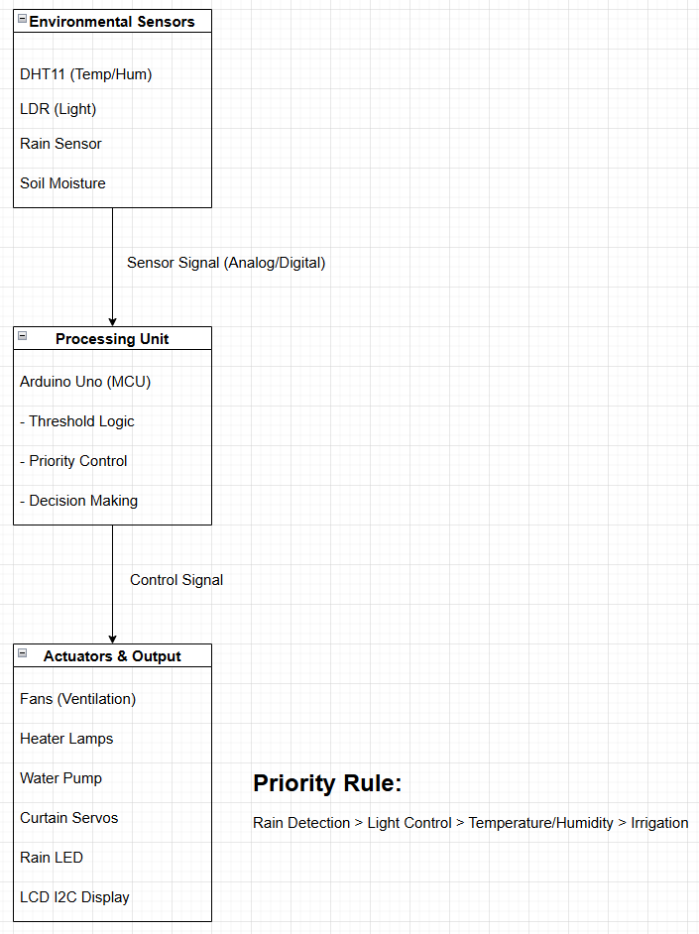
Figure 1: Overall Functional Block Diagram of the Smart Greenhouse System
Diagram Description
The overall system block diagram illustrates the high-level architecture of the smart greenhouse control system. The design is organized into three logical layers:
- Input Layer (Sensors)
Environmental parameters including temperature, humidity, light intensity, rainfall, and soil moisture are continuously measured using dedicated sensors. These sensors generate digital or analog signals representing real-time greenhouse conditions.
- Processing Layer (Control Unit)
The Arduino Uno microcontroller serves as the central processing unit. It receives sensor data, applies threshold-based and priority-based control algorithms, and determines appropriate actions for each subsystem. Rain detection is assigned the highest priority to ensure immediate crop protection.
- Output Layer (Actuators & Display)
Based on control decisions, the Arduino drives actuators such as fans, heaters, irrigation pumps, and curtain servos through isolated driver circuits. System status and environmental values are displayed on the I2C LCD, while LEDs provide visual warning indicators.
This block-based architecture improves system clarity, scalability, and reliability, and it provides a clear foundation for both simulation and future hardware implementation.

3.3 Hardware Design

3.3.1 System Architecture
The system comprises three main functional blocks:
- Environmental Sensing
- Control Unit (Arduino)
- Actuation & Indicators
These blocks interact through digital and analog signal lines to monitor environmental parameters and drive actuators accordingly.

3.3.2 Circuit Overview
- Sensor Interfaces
  - Temperature/Humidity: DHT11 (digital sensor)
  - Light: LDR (analog voltage divider)
  - Rain: Rain sensor module (digital logic state)
  - Soil Moisture: Moisture sensor with digital output
- Actuators & Output Devices
  - Dual Servo Motors for curtain control
  - Fan (ventilation)
  - Heater (lamp)
  - Water Pump (irrigation)
  - LED indicator for rain detection
  - LCD 20×4 display via I2C
These components connect to Arduino digital and analog pins using proper power regulation and driver circuits (e.g., relays or transistors) to handle load requirements safely.

3.3.3 Explain the motor circuit
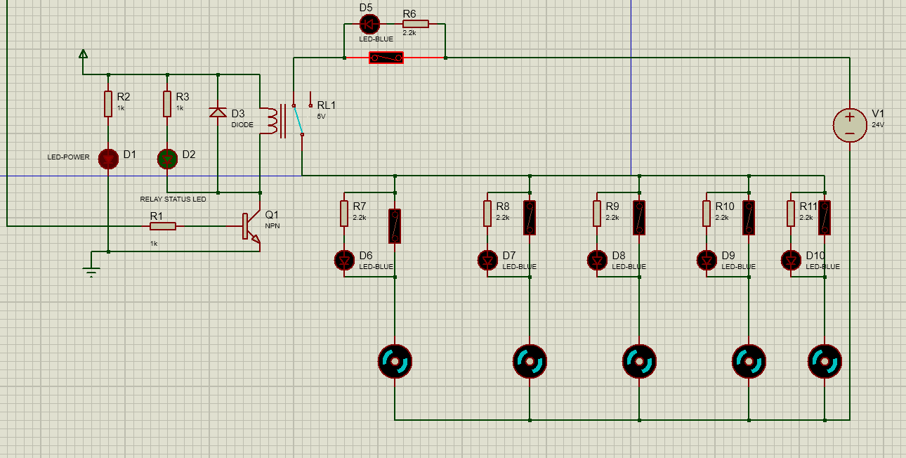
Figure 2: Motor Circuit
Circuit Overview
This is an isolated control circuit designed to interface a low-voltage control signal (5V) with a high-power load (24V).
- Load: 5 Fans (80W each).
- Key Feature: Individual "Blown Fuse Indicators" for each fan.
1. Control Circuit (Left Side - Low Voltage)
This section acts as an electronic switch to turn the main power on or off.
- Input Signal: A 5V Logic High signal is applied to resistor R1.
- Transistor Q1 (NPN): Acts as the driver. When the input signal is High, current flows into the Base, turning Q1 ON (conducting current from Collector to Emitter).
- Relay (RL1):
- When Q1 conducts, the Relay Coil is energized.
- The Relay Contact (Switch) closes, connecting the 24V source to the fans.
- Protection & Status:
- D3 (Flyback Diode): Protects Transistor Q1 from high-voltage spikes (back EMF) generated by the relay coil when it turns off.
- D2 (Status LED): Lights up when the Relay is active (System is ON).
2. Power Circuit & Blown Fuse Logic (Right Side - High Voltage)
This is the high-current section driving the fans.
- Power Source: 24V DC (V1).
- The Load: 5 Fans connected in parallel.
- Current per Fan: I = P/U = 80W / 24V = 3.33A.
- Total System Current: 16.7A (Continuous) + High Inrush Current at startup.
The Blown Fuse Indicator Mechanism
In your Proteus schematic, the Switches placed in parallel with the Resistor + LED combination represent Fuses.
How it works:
1. Normal Operation (Fuse is Intact/Closed):
- Current flows through the Fuse because it has near-zero resistance (path of least resistance).
- The current effectively bypasses (shunts) the LED circuit.
- Result: Fan runs, LED is OFF.
2. Fault Condition (Fuse is Blown/Open):
- The direct path is broken. Current is forced to flow through the parallel path: 24V - Resistor (2.2k) - LED - Fan Motor - Ground.
- The 2.2k resistor limits the current to a very small value (= 10mA). This current is too weak to run the fan, but enough to light up the LED.
- Result: Fan stops, LED turns ON.
- Purpose: This alerts the operator immediately which specific fuse has blown.
3.Engineering Significance of the Circuit Design
The proposed circuit design prioritizes operational reliability and safety by electrically isolating the sensitive 5V control logic from the high-power 24V loads using relays, effectively preventing damage from electrical noise and voltage surges. Component durability is further reinforced by the inclusion of Flyback Diodes (D3), which suppress high-voltage back EMF spikes to protect the transistor drivers. Furthermore, the system ensures operational continuity through a parallel fan configuration that prevents total system shutdown in case of a single failure, while the integrated "Blown Fuse Indicator" mechanism enables instant visual fault detection, significantly reducing maintenance downtime.

3.3.4 Explain the LCD control circuit
1. Main Function This circuit helps save microcontroller pins. Instead of using 6-10 wires to connect directly to the LCD, you only need 2 signal wires (SDA and SCL) to control the display.
2. Component Analysis
- U2 (PCF8574): This is the interface IC (I/O Expander).
- It receives serial data from the microcontroller via the SDA and SCL pins.
- It decodes the data and toggles the parallel output pins (P0-P7) to control the LCD.
- Pins A0, A1, A2 are connected to ground (GND) to set the I2C address (typically 0x20 or 0x27).
- LCD1 (LM044L): Character display screen.
- It is connected to U2 in 4-bit mode (using only data pins D4, D5, D6, D7) to reduce the number of connections.
- Control pins RS, RW, E are connected to P0, P1, and P2 of U2, respectively.
3. Engineering Significance of the I2C LCD Interface
The implementation of the I2C LCD interface significantly optimizes hardware resources by reducing the required connections from 6-10 parallel pins to just two signal lines (SDA/SCL), thereby preserving critical I/O pins for other essential sensors and actuators. This streamlined architecture enhances system reliability by minimizing physical wiring, which mitigates the risks of loose contacts and electromagnetic interference in the vibration-prone greenhouse environment. Furthermore, the addressable nature of the I2C bus ensures system scalability, facilitating the seamless integration of additional devices without the need for complex rewiring or additional microcontroller ports.

3.3.5 Explanation of circuit for climate and irrigation regulation
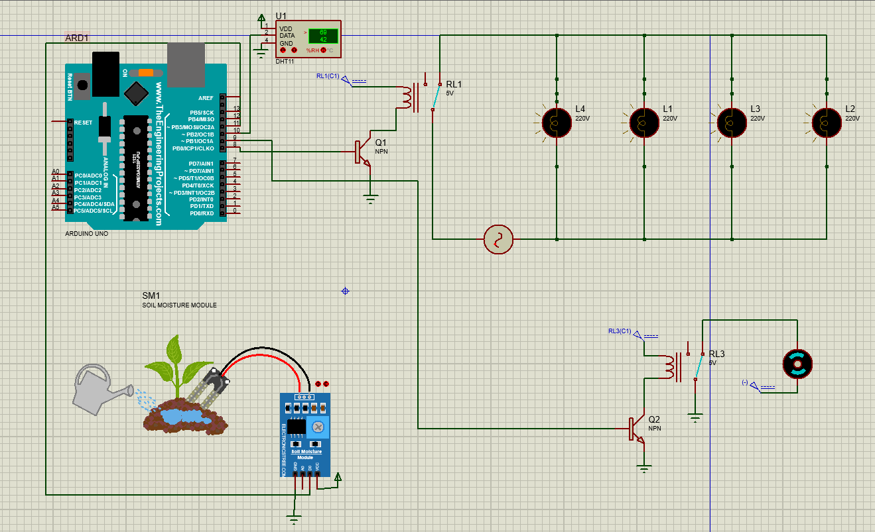
Figure 3: Circuit for climate and irrigation regulation
The system is designed based on threshold-based control, with Arduino acting as the central processor . Arduino is responsible for collecting environmental data from sensors, processing input signals, and making decisions to control actuators to maintain suitable growing conditions for the plants.
1. Input Signal Collection and Processing
Environmental data is provided to the Arduino Uno through two main signal channels:
- DHT11 Temperature and Humidity Sensors :
The DHT11 sensors use a digital communication protocol to send temperature and humidity data to the microcontroller . Arduino reads the current temperature value and compares it to a pre-set temperature threshold suitable for each type of plant .
When the ambient temperature falls below the allowed threshold, Arduino sends a control signal to activate the heating lamp, increasing the temperature inside the cultivation area.
- Soil Moisture Sensor :
The soil moisture sensor converts the soil moisture level into an analog voltage signal. This signal is fed into the Arduino Uno's 10-bit ADC converter, allowing the voltage to be converted into a digital value ranging from 0 to 1023.
When the measured moisture value is lower than the set soil moisture threshold, the Arduino will activate the water pump to irrigate the plants.
By comparing the sensor values with predefined thresholds, the system can automatically make control decisions without constant user intervention.
2. Actuator Control and Power Isolation Circuit
Because the Arduino Uno only operates at low voltage (5V) and limited current, while actuators such as heaters and water pumps require higher voltage and current, an intermediate control circuit is used to ensure the safety and stability of the system.
- Amplifier and Switching Stage
Each actuator is controlled via an NPN transistor coupled with a relay. The transistor acts as an electronic switch, allowing a small current from the Arduino to control a large current flowing through the relay coil.
A current-limiting resistor is connected to the base of the transistor to ensure the transistor operates within the saturation region and prevent overcurrent.
- Control Circuit Isolation and Protection
The relay completely isolates the low-voltage control circuit from the power circuit of the heater and pump, protecting the Arduino Uno from high-voltage incidents.
- Reverse Voltage Surge Protection
A flyback diode is connected in reverse parallel with the relay coil to suppress voltage surges generated when the relay suddenly switches off. This protects the transistor and microcontroller from voltage spikes.
3. Overall Control Principle of the System
Based on signals collected from sensors, the Arduino Uno performs the following control functions:
- Turning the heating lamp on/off when the ambient temperature is lower or higher than the set threshold.
- Turning the water pump on/off when the soil moisture level is lower than the required level for plants.
This threshold-based control mechanism makes the system simple, stable, and suitable for small and medium-scale greenhouse models, while also being easy to expand or upgrade in subsequent research .
4. Technical Significance:
This control system provides a practical and scalable approach to automated greenhouse management. By using threshold-based logic and sensor feedback, it ensures that plants receive optimal temperature and moisture levels with minimal human intervention. The integration of isolation circuits and surge protection enhances system reliability, preventing damage to low-voltage electronics while safely controlling high-power actuators. Furthermore, the modular design allows easy expansion to include additional sensors, actuators, or control logic, making the system suitable for both research prototypes and small to medium-scale practical greenhouses.

3.3.6 Explanation of circuit for Rain Detection, Light Monitoring, and Curtain Control

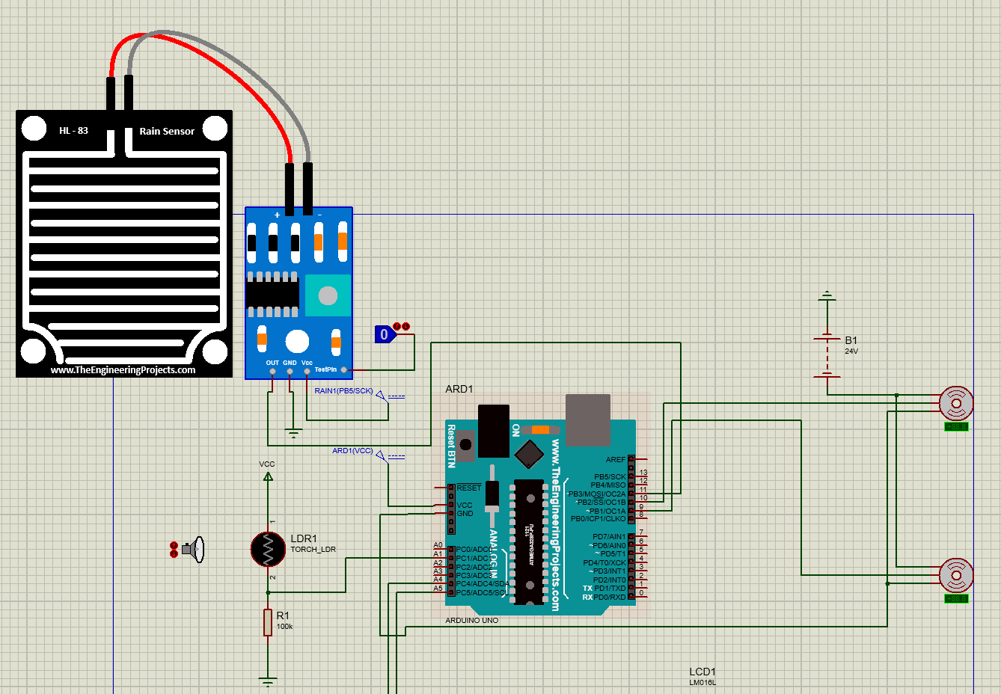
Figure 4:Circuit for Rain Detection, Light Monitoring, and Curtain Control
The circuit shown in Figure illustrates the environmental protection subsystem of the smart greenhouse, which focuses on rain detection, ambient light monitoring, and automatic curtain control.
This subsystem plays a critical role in protecting crops from unfavorable weather conditions such as heavy rain or excessive sunlight. The Arduino Uno acts as the central controller, processing sensor inputs and controlling mechanical actuators accordingly.
1. Input Signal Collection and Processing
Environmental data is collected through two main types of sensors: rain sensor and light intensity sensor.
• Rain Sensor (HL-83 Module)
The rain sensor consists of a rain detection plate and a signal conditioning module. When raindrops fall onto the sensor plate, the resistance between conductive traces changes, causing a variation in the output voltage.
- The sensor module converts this variation into a digital signal through an onboard comparator.
- The digital output is connected to one of the Arduino Uno’s digital input pins.
- When rain is detected (logic HIGH/LOW depending on calibration), the Arduino identifies a rain condition.
This allows the system to respond immediately to rainfall events, which is essential for greenhouse structural protection.
• Light-Dependent Resistor (LDR)
The LDR is used to monitor ambient light intensity inside or around the greenhouse.
- The LDR is connected in a voltage divider configuration with a fixed resistor.
- The resulting analog voltage is proportional to light intensity and is fed into the Arduino Uno’s 10-bit ADC via an analog input pin.
- The ADC converts this voltage into a digital value ranging from 0 to 1023, representing low to high light levels.
The Arduino continuously compares this value against a predefined light threshold to determine whether the environment is too bright or adequately shaded.
2. Actuator Control and Power Interface
Based on the processed sensor data, the Arduino controls servo motors that operate the greenhouse curtain mechanism.
• Servo Motor Control
- The servo motors are driven directly by the Arduino using PWM (Pulse Width Modulation) signals.
- Each servo receives:
  - A control signal from a digital PWM pin,
  - A 24V supply, each servo consumes 15 watts.
  - A common ground.
- By adjusting the PWM duty cycle, the Arduino precisely controls the angular position of the servo.
This enables smooth opening or closing of the greenhouse curtain rather than abrupt mechanical motion, reducing mechanical stress and increasing system reliability.
3. Priority-Based Control Logic
Unlike simple threshold-based systems, this circuit is designed with logical prioritization between environmental parameters:
- Rain detection has the highest priority:
  - When rain is detected, the Arduino immediately commands the servos to close the greenhouse curtain, regardless of light conditions.
- Light-based control is applied only when no rain is detected:
  - If light intensity exceeds the preset threshold, the curtain is partially or fully closed to reduce excessive sunlight.
  - If light intensity is within acceptable limits, the curtain remains open to allow natural illumination.
This priority mechanism prevents conflicting actions, such as opening the curtain for light while rain is present.
4. Overall Control Principle of the Subsystem
The operating logic of this subsystem can be summarized as follows:
- Detect rainfall using the rain sensor.
- Measure ambient light intensity using the LDR.
- If rain is detected → close the curtain immediately.
- If no rain is detected:
  - Close the curtain when light intensity is too high.
  - Open the curtain when light conditions are suitable.
This design ensures environmental protection, energy efficiency, and mechanical safety, making it highly suitable for realistic smart greenhouse applications.
5. Engineering Significance
The integration of rain sensing, light monitoring, and servo-controlled curtains provides several advantages:
- Prevents crop damage caused by rain and excessive sunlight.
- Reduces unnecessary actuator operation, improving system longevity.
- Demonstrates a realistic and scalable control strategy, closely resembling commercial greenhouse automation systems.
This subsystem significantly enhances the practical applicability of the proposed smart greenhouse control system.

3.4 Component Selection
Component selection plays a crucial role in ensuring the smart greenhouse system operates stably, accurately, and in line with the project's learning and research objectives. Components are selected based on key criteria including: functional suitability, availability, reasonable cost, prototyping in Proteus, and scalability in practice.

3.4.1 Microcontroller Unit (MCU)
Arduino Uno was chosen as the central controller of the system because of these reasons :
- Arduino Uno has a simple architecture, is easy to program, and is suitable for basic embedded systems.
- It fully supports digital and analog I/O pins, meeting the requirements for connecting multiple sensors and actuators.
- It is highly compatible with the Proteus simulation software, making it easy to test and evaluate the system before real-world deployment.
- A large support community and abundant documentation facilitate learning and development.
Comparison with other options:
- ESP8266/ESP32 have integrated Wi-Fi but are more complex and unnecessary for the project's main objective.
- PLCs offer high stability but are expensive and unsuitable for student research models.
Therefore, Arduino Uno is the optimal choice between features, cost, and research objectives.

3.4.2 Temperature and Humidity Sensor
The DHT11 sensor is used to measure temperature and humidity in the greenhouse.
Reasons for selection:
- DHT11 integrates temperature and humidity measurement in a single module, simplifying hardware design.
- The measurement range is suitable for vegetable growing environments (0–50°C, 20–90% RH).
- Low cost, readily available, and easy to simulate in Proteus.
- The readily available programming library reduces the complexity of software development.
Comparison with other sensors:
- The DHT22 has higher accuracy but is more expensive and exceeds the model's requirements.
- The LM35 only measures temperature, not humidity, so it doesn't fully meet the environmental monitoring requirements.

3.4.3 Soil Moisture Sensor
The soil moisture sensor was chosen to determine the soil moisture status., which provides an analog output proportional to the water content in the soil :
- Provides an analog signal easily processed by Arduino.
- Suitable for controlling automatic irrigation systems.
- Low cost, widely available, and easy to simulate.
- Suitable for short-cycle crops and leafy vegetables.
Comparison with other solutions:
- Capacitive sensors have higher durability but are more expensive and difficult to simulate in Proteus.
- Time-based irrigation methods do not accurately reflect the plant's water needs.

3.4.4 Light Intensity Sensor
The Light Dependent Resistor (LDR) sensor is used to measure light intensity in the greenhouse.
Factors influencing component selection:
- Simple operating principle, easy integration with Arduino.
- Suitable for assessing relative light levels (sufficient/insufficient).
- Low cost and easy to simulate.
- Meets the requirements for controlling supplementary lighting systems.
- Comparison with other sensors:
- The BH1750 sensor provides more accurate lux values but is not necessary for basic control purposes.
- The LDR is sufficient for learning and testing models.

3.4.5 Rain Sensor
The rain sensor is integrated into the system to detect rainfall conditions and enable timely protective actions for crops grown inside the greenhouse.
Reasons for selection:
- The sensor provides both digital and analog outputs, allowing the system to detect the presence of rain as well as estimate rainfall intensity if required.
- High sensitivity of the sensing surface ensures reliable detection even under light rainfall conditions, which is critical for early protective response.
- The rain sensor operates effectively in conjunction with the servo motor mechanism to automatically close the greenhouse roof or curtain, helping to prevent waterlogging, excessive humidity, and physical damage to sensitive crops.
- The sensor is fully supported in the Proteus simulation environment, enabling accurate testing of weather-priority control logic during system simulation.
Comparison with other approaches:
- Manual monitoring depends heavily on human presence and reaction time, making it unreliable during sudden or unexpected weather changes.
- Weather API–based solutions require constant internet connectivity and may not accurately represent localized weather conditions at the greenhouse site.
Therefore, the hardware-based rain sensor provides a fast, localized, and reliable solution for precipitation detection, enhancing the autonomy and responsiveness of the smart greenhouse system.

3.4.6 Actuators
The system employs several actuators to maintain optimal growing conditions for plants. Selected actuators include:
- Relay module: Controls high-power devices such as the water pump, ventilation fan, and lighting system.
- DC fan: Facilitates air circulation and reduces greenhouse temperature.
- Water Pump: Supports the automatic irrigation system by delivering water when soil moisture is below the threshold.
- Lamp: Simulates supplementary lighting for adequate plant illumination.
- Curtain servo: Automates the opening and closing of the greenhouse curtain or roof based on light intensity and rain detection, protecting plants from excessive sunlight and water exposure.
Reasons for actuator selection:
- Relay module: Allows Arduino Uno to safely switch high-power devices. It is common, easy to implement, and suitable for Proteus simulation. Low cost makes it ideal for research models.
- DC fan, water pump, lamp: Compatible with relay control and effectively simulate real greenhouse conditions.
- Curtain servo: Provides precise mechanical control for shading and protection. Integrates easily with Arduino and is compatible with automated sensor-based responses.

3.4.6 Display and User Interface
A 16x2 LCD is used to display environmental parameters such as temperature, humidity, and system status.
Key considerations for selection :
- Clear and easy-to-read display.
- Simple communication via I2C, saving connection pins.
- Suitable for systems that do not require a complex interface.

3.4.7 Power Consumption Analysis and Power Supply Selection
To ensure system stability and prevent overload, a detailed power consumption analysis was conducted based on the component specifications. The system is divided into three distinct voltage domains: 5V (Logic), 24V (DC Actuators), and 220V (AC Heaters).

A. Control Logic Unit (5V DC)
Powering Arduino, Sensors, LCD, and Relay Coils.
Component | Quantity | Voltage (V) | Current (A) | Power (W) | Notes
Arduino Uno | 1 | 5 | 0.05 | 0.25
LCD 2004 (I2C) | 1 | 5 | 0.06 | 0.30 | Backlight ON
Sensors (DHT11, Rain, etc.) | 4 | 5 | 0.05 | 0.25 | Combined
Relay Module (Coil Trigger) | 3 | 5 | 0.21 | 1.05 | 3 Relays Active (~70mA each)
Subtotal (5V) |  |  | ~ 0.4A | ~ 2W | Low Load

B. DC Actuation Unit (24V DC)
Powering High-Power Fans, Water Pump, and Servos.
Component | Quantity | Voltage (V) | Current (A) | Power (W) | Notes
Ventilation Fan (80W) | 5 | 24 | 16.65 | 400.0 | 3.33A per fan
Water Pump | 1 | 24 | 0.92 | 22.0
Servo Motor (High Torque) | 2 | 24 | 2.00 | 48.0 | Est. 1A per servo (Active)
Subtotal (24V) |  |  | ~ 19.6A | ~ 470W | High Load

C. AC Heating Unit (220V AC)
Powering Heating Lamps.
Component | Quantity | Voltage (V) | Current (A) | Power (W) | Notes
Heating Lamp | 4 | 220 | 0.90 | 200.0 | 4 x 50W Bulbs
Subtotal (220V) |  |  | ~ 0.9A | 200W

3.4.8 Summary of Component Selection
Component selection in this project was based on a balance between functionality, cost, simulation capabilities, and learning objectives. The selected components are common, easy to implement, and scalable, laying the groundwork for the development of a larger-scale smart greenhouse system in the future.

3.5 Software & Algorithm Design
The system logic is designed to be modular, corresponding to the hardware functional blocks. Decision-making follows a priority-based control scheme that avoids conflicting actuation commands and optimizes resource usage.

3.5.1 Functional Blocks
The core software logic is divided into:
- Curtain Control (Rain + Light)
- Temperature/Humidity Regulation
- Irrigation Control
Each block reads relevant sensors and controls actuators through threshold-based decisions.

3.5.2 Control Logic Principles
Rule-based Threshold Control:
- Actuators are triggered only when sensor criteria are met.
- Rain overrides light-based curtain logic.
- Temperature thresholds determine fan or heater activation.
- Soil moisture directly controls pump behavior.
This strategy aligns with common control approaches in embedded greenhouse systems, providing reliable and efficient operation.

3.6 Flowchart & Pseudocode

3.6.1 Overall Flowchart
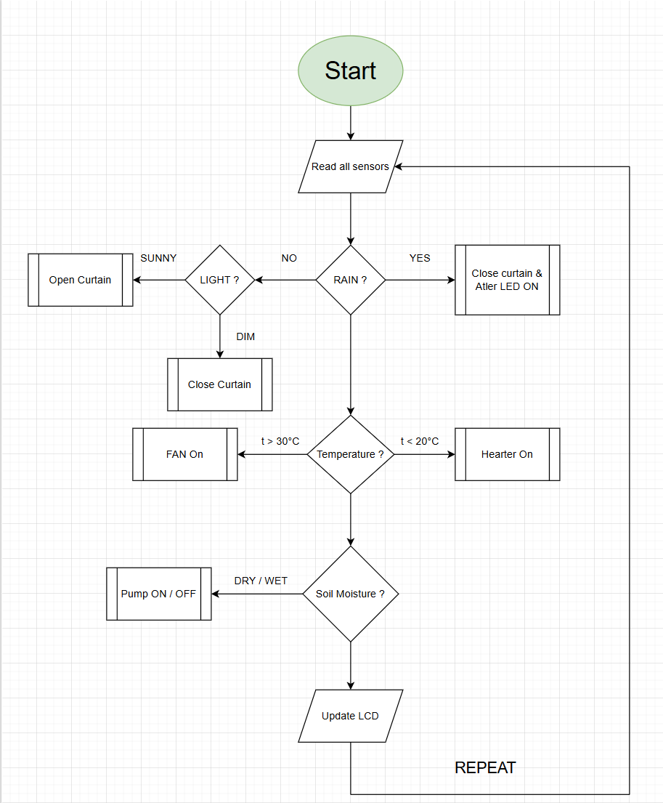
Figure 5: Flowchart

3.6.2 Pseudocode Example
LOOP:
readRain
IF rainDetected:
closeCurtain
turnOnRainLED
ELSE:
readLight
IF highLight:
openCurtain
ELSE if lowLight:
closeCurtain

readTempHumidity
IF highTemp:
turnOnFan
ELSE IF lowTemp:
turnOnHeater

readSoilMoisture
IF soilDry:
turnOnPump
ELSE:
turnOffPump

updateDisplay
END LOOP;

3.7 Reliability & Safety Measures
- Debounce and sampling intervals prevent sensor noise from triggering spurious actions.
- Priority logic ensures rain protection takes precedence over other conditions.
- Actuators such as pumps and fans are driven through isolated relay circuits to protect the microcontroller.

3.8 Summary
This chapter presented the detailed technical blueprint of the smart greenhouse system, including hardware architectures, rationalized component selection, and software control strategies. The design is modular, low-cost, and ready for simulation and real-world implementation.

CHAPTER 4. SIMULATION & EVALUATION

4.1 Introduction
This chapter presents the simulation setup, experimental scenarios, and performance evaluation of the designed Smart Greenhouse system. Simulation plays a crucial role in validating the feasibility of the control solution before physical implementation. The Proteus Design Suite 8.13 software is utilized to analyze system behavior under various simulated environmental conditions, ensuring consistency between theoretical theory, the control source code, and the schematic design.
The objectives of this chapter are to demonstrate that the system achieves the following requirements:
- Accurate Operation: The system responds correctly to programmed sensor thresholds.
- Priority Logic: The system executes priority commands correctly (e.g., prioritizing rain protection over light conditions).
- Reliability: The warning systems (LCD interface, Blown Fuse Indicators) operate visually and reliably.

4.2 Simulation Environment

4.2.1 Implementation Tools
The simulation process is conducted using a combination of hardware design and software programming tools:
- Proteus Design Suite 8.13: Used for schematic design and real-time simulation of sensors (DHT11, LDR, Rain Sensor) and actuators (Motors, Servos, Relays).
- Arduino IDE: Used for code development, compilation, and generating the .HEX file to upload to the microcontroller within the simulation.

4.2.2 Simulated Hardware Configuration
The simulation schematic in Proteus includes the main functional blocks corresponding to the design in Chapter 3:
- Central Control Block: Arduino Uno R3.
- Sensor Block:
  - DHT11: Simulates temperature and humidity changes.
  - LDR (Light Dependent Resistor): Simulates light intensity (Day/Night).
  - Rain Sensor & Soil Moisture: Uses Logic Toggles in TestPin each sensor to simulate Rain/No Rain and Dry/Wet Soil states.
- Display Block: LCD 20x4 connected via I2C interface (PCF8574) to conserve microcontroller pins.
- Actuator Block:
  - DC Motors (Simulating 80W Fans) and Lamps (Simulating Heaters) controlled via Relays.
  - Blown Fuse Indicator System: Individual fault detection for each load branch.
  - Two Servo Motors for automatic curtain/roof control.

4.3. Simulation Scenarios
To evaluate reliability, the system was tested through 5 specific scenarios representing real-world conditions. Input parameters were manually adjusted in Proteus.

4.3.1. Scenario 1: Temperature Control (Heat/Cold Stress)
- Objective: Test the response of the Fan and Heater based on set thresholds (T{hot} > 30, T{cold} < 20).
- Setup:
  - Case 1: Increase DHT11 temperature to 35.
  - Case 2: Decrease DHT11 temperature to 15.
- Expected Result:
  - When T > 30: Fan Relay closes (Fan ON), Heater OFF. LCD displays "Fan: ON".
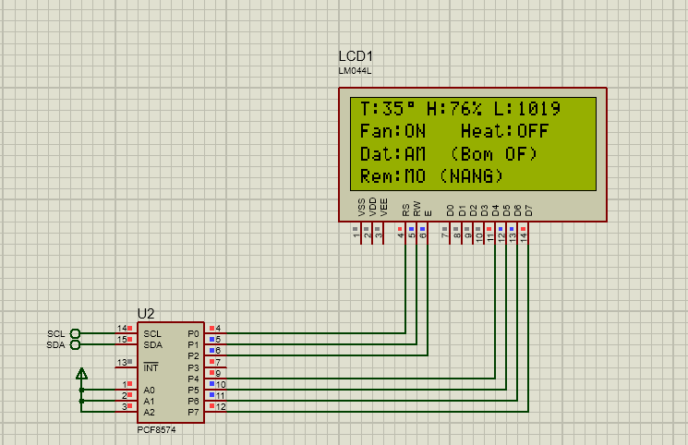
Figure 6: LCD Case 1 – Scen1
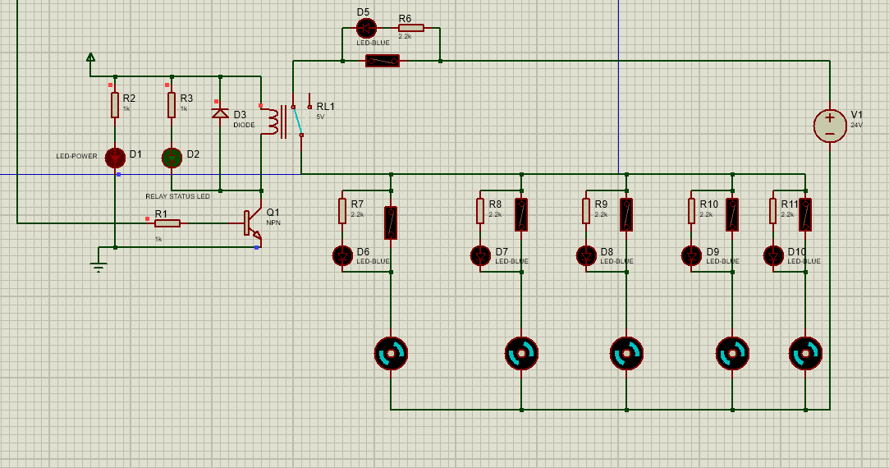
Figure 7: Fan system
- When T < 20 Heater Relay closes (Heater ON), Fan OFF. LCD displays "Heat: ON".
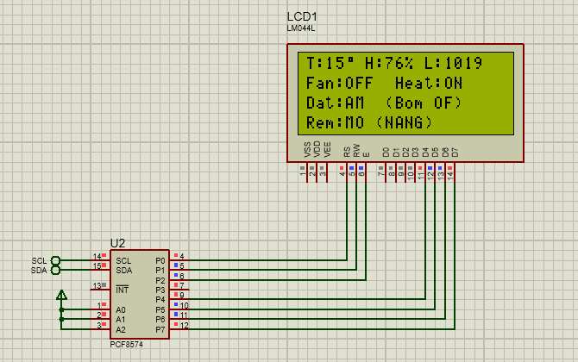
Figure 8: LCD Case 2 – Scen1
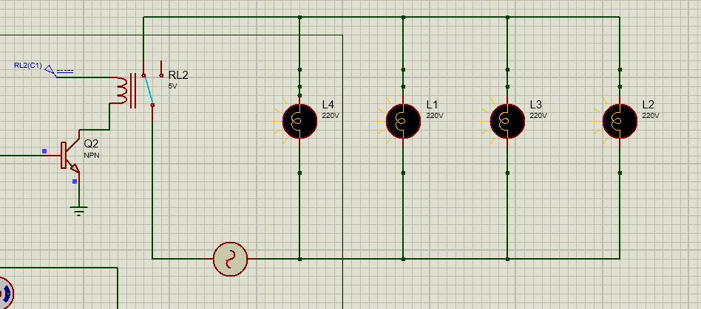
Figure 9: Lamp system

4.3.2. Scenario 2: Rain Response (Priority Logic)
- Objective: Verify the safety feature that automatically closes the curtain during rain, regardless of light conditions.
- Setup: Rain Sensor pin is toggled to logic LOW (Simulating Rain).
- Expected Result:
- Servos rotate to -90 (Close Curtain) AND Warning LED (LED_PIN) turns ON.
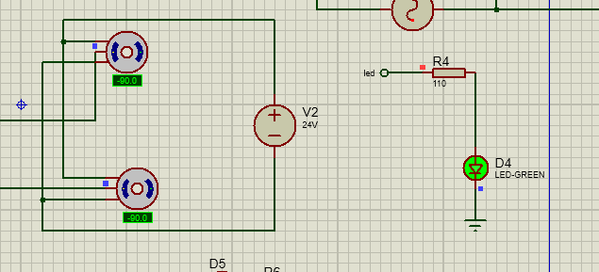
Figure 10: Servo system closes curtain when rain
- LCD displays warning: "!MUA TO! DONG REM" (HEAVY RAIN! CLOSING CURTAIN).
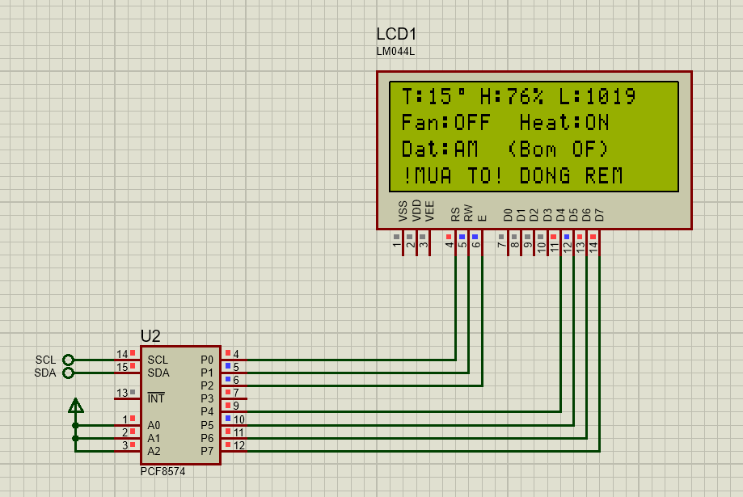
Figure 11: LCD Scen2

4.3.3. Scenario 3: Light-Based Curtain Control (Auto Mode)
- Objective: Test curtain operation under normal weather conditions (No Rain).
- Setup: Rain Sensor set to HIGH (No Rain). Adjust LDR values:
- High Light (Sunny): LDR Value > 700.
- Low Light (Dark/Cloudy): LDR Value < 400.
- Expected Result:
- Sunny: Servos slowly rotate to 90 (Open Curtain). LCD: "Rem: MO (NANG)".
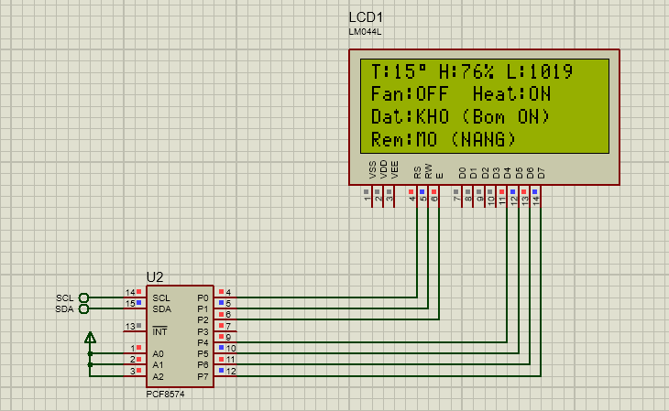
Figure 12: LCD Scen3 - 1
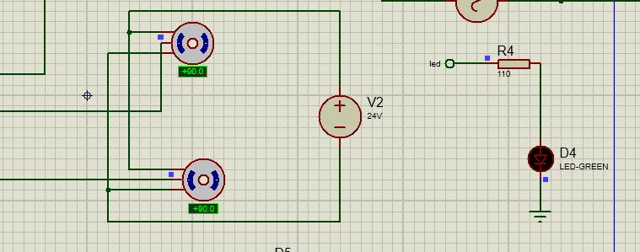
Figure 13: Servo system opens curtain when sunny
- Dark: Servos rotate to -90 (Close Curtain to retain heat). LCD: "Rem: DG (TOI)".
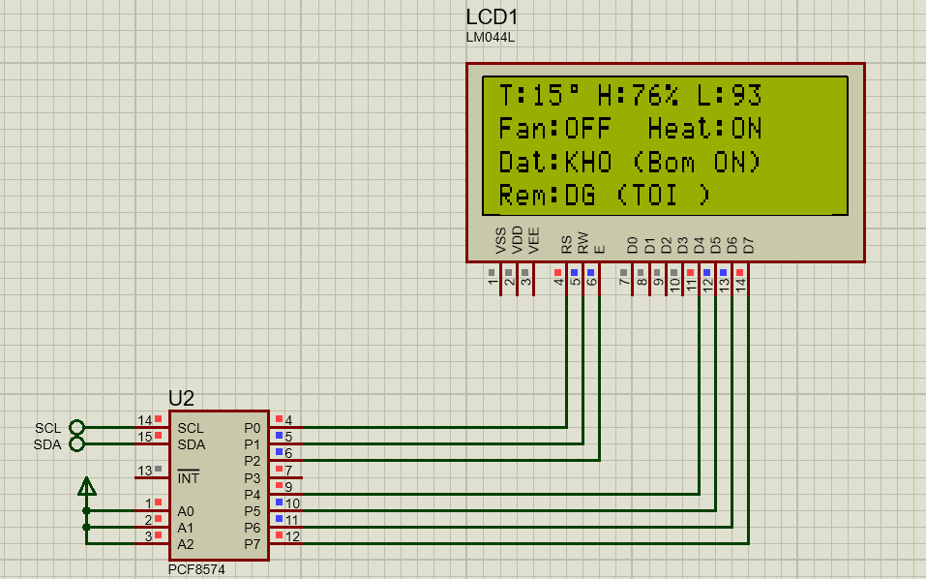
Figure 14: LCD Scen 3 - 2
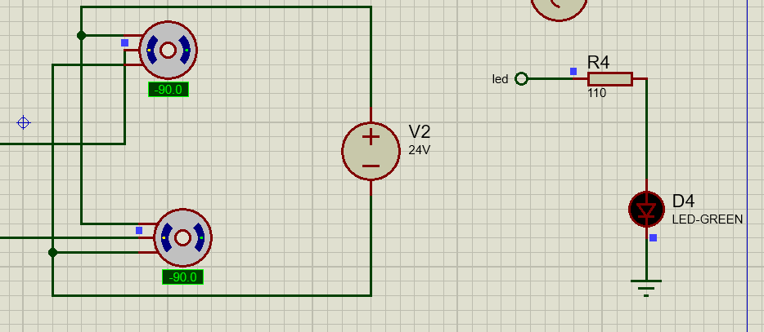
Figure 15: Servo system closes curtain when dark

4.3.4. Scenario 4: Automated Irrigation System
- Objective: Test response to soil moisture levels.
- Setup: Soil Sensor pin (SOIL_PIN) set to logic HIGH (Dry Soil).
- Expected Result:
- Pump Relay activates (Pump ON).
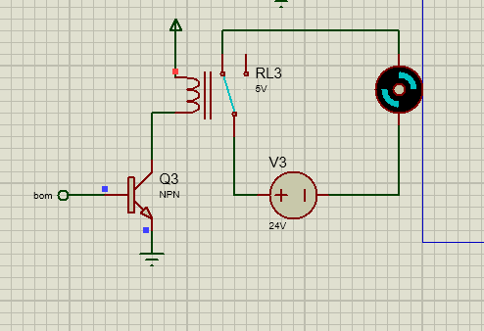
Figure 16: Pump
- LCD Line 3 displays: "Dat: KHO (Bom ON)" (Soil: DRY - Pump ON).

Figure 17: LCD Scen4

4.3.5. Scenario 5: Blown Fuse Indicator Test (Fault Condition)
- Objective: Confirm that the fault indication circuit operates as designed.
- Setup: On the power circuit, open the switch representing the Fuse for Fan #1 (Simulating a blown fuse).
- Expected Result:
- The Fan motor stops spinning.
- The Error LED connected in parallel with that specific fuse turns ON, indicating the exact location of the fault.
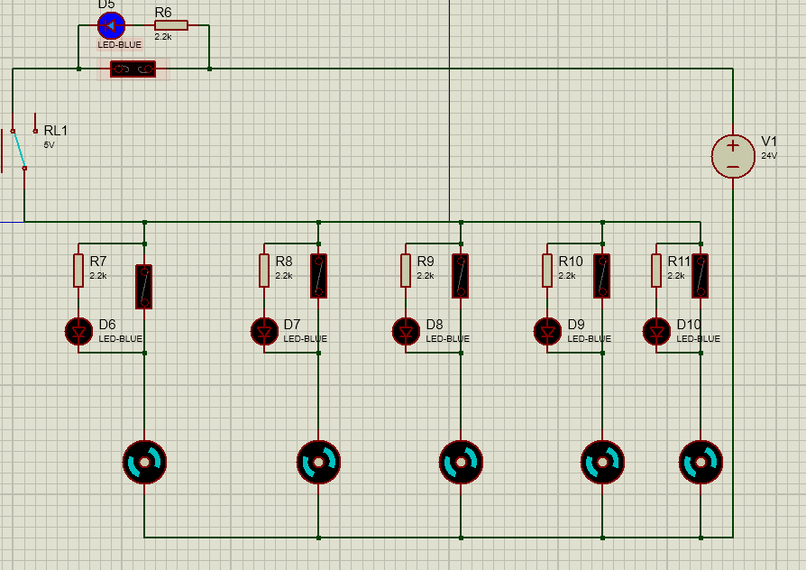
Figure 18: Fan system when error

4.4. Result Analysis

4.4.1. Functional Assessment
Simulation results demonstrate a high degree of consistency between theory and Proteus experimentation:
- Sensor Readings: The microcontroller accurately interprets data from the DHT11 and Digital/Analog sensors.
- Control Logic:
- The "Non-blocking" mechanism (using millis() instead of delay()) allows the Servos to move smoothly while simultaneously reading sensors.
- Priority Logic (Rain > Sun) functions correctly: The curtain closes immediately upon rain detection, even if the LDR indicates high light intensity.
- User Interface: The LCD updates parameters every 0.5 seconds without flickering or latency.

4.4.2 Simulation Results Summary Table
Parameter | Input Condition | Design State | Simulation Result | Assessment
Temperature | > 30 | Fan ON, Heater OFF | Fan ON, Heater OFF | Pass
Temperature | < 20 | Fan OFF, Heater ON | Fan OFF, Heater ON | Pass
Rain | Raining (Logic 0) | Curtain Close, LED ON | Curtain Close, LED ON | Pass
Light | Sunny (High LDR) | Curtain Open | Curtain Open (180) | Pass
Soil Moisture | Dry Soil (Logic 1) | Pump ON | Pump ON | Pass
Fault Event | Blown Fuse | Error LED ON | Error LED ON | Pass

4.5 Feasibility for Real Implementation
Based on the simulation results, the system is evaluated as feasible for hardware implementation due to the following reasons:
- Electrical Safety: The circuit design includes Optocoupler/Relay isolation and individual fuses protecting high-power loads (80W Fans).
- System Stability: The code utilizes timer-based logic (Millis()), ensuring stable multitasking over long periods.
- Maintenance Friendly: The Blown Fuse Indicator feature allows operators to quickly identify faults without the need for external measuring instruments.

4.6 Chapter Summary
Chapter 4 has conducted a comprehensive system simulation in Proteus using realistic scenarios. The system successfully met all requirements regarding automation, monitoring, and safety warnings. These results provide a solid foundation for PCB fabrication and physical model assembly in the next phase of the project.

CHAPTER 5. CONCLUSION AND FUTURE WORK

5.1 Conclusion
This project presented the design and simulation of a smart greenhouse control system using Arduino, aiming to improve environmental monitoring and control in modern agricultural applications. By integrating multiple sensors, actuators, and a centralized microcontroller, the system provides automated regulation of critical greenhouse parameters, including temperature, humidity, light intensity, rainfall, and soil moisture.
A modular system architecture was proposed, dividing the greenhouse into three independent functional subsystems:
- Weather and curtain control
- Temperature and humidity regulation
- Soil moisture and irrigation management
This functional separation ensures logical clarity, prevents unnecessary actuator activation, and enhances system reliability. The control strategy is based on threshold-driven decision-making, which is computationally efficient and suitable for low-cost embedded platforms such as Arduino.
Comprehensive simulation using Proteus Design Suite demonstrated that the system behaves consistently with its theoretical design. All simulated scenarios—including extreme environmental conditions—confirmed correct sensor interpretation, appropriate actuator response, and stable system operation. The close alignment between simulation results and design expectations validates the feasibility of the proposed system for real-world deployment.

5.2 Engineering Significance
From an engineering perspective, this project demonstrates:
- Practical application of embedded systems in agriculture
- Integration of sensors, actuators, and control logic into a unified system
The importance of simulation-based validation prior to physical implementation
The system design follows an engineering workflow: problem identification → system design → simulation → evaluation, making it suitable as both an academic project and a foundation for commercial development.

5.3 Limitations
Despite successful simulation results, certain limitations remain:
- The simulation environment does not fully capture sensor noise, signal drift, or mechanical wear.
- Power consumption optimization was not deeply analyzed.
- The system operates based on fixed thresholds, which may not adapt optimally to changing environmental patterns.
These limitations highlight opportunities for further improvement and real-world testing.

5.4 Future Work
To enhance system performance and scalability, the following future developments are proposed:
- IoT Integration
Replace Arduino Uno with ESP32 or similar microcontrollers to enable wireless data transmission, remote monitoring, and cloud-based control.
- Advanced Control Algorithms
Implement adaptive or fuzzy logic control to dynamically adjust thresholds based on environmental trends.
- Data Logging and Analytics
Store sensor data locally or in the cloud to support long-term analysis and predictive decision-making.
- Energy Optimization
Integrate solar power and optimize actuator scheduling to reduce energy consumption.
- Real-World Deployment and Testing
Construct a physical prototype to evaluate system performance under real environmental conditions and validate long-term reliability.

5.5 Final Remarks
The proposed smart greenhouse control system demonstrates a practical and scalable solution for automated agriculture. With validated simulation results and a clear pathway for future enhancements, this project provides a strong technical foundation for further research, real-world implementation, and potential commercialization

APPENDIX

A. Source Code — Arduino
#include <Wire.h>
#include <LiquidCrystal_I2C.h>
#include <DHT.h>
#include <Servo.h>

#define FAN_PIN 2
#define HEATER_PIN 8
#define DHTPIN 13
#define DHTTYPE DHT11
const float TEMP_HOT_LIMIT = 30.0;
const float TEMP_COLD_LIMIT = 20.0;

const int RAIN_PIN = 11;
const int LDR_PIN = A1;
const int LED_PIN = 3;
const int SERVO1_PIN = 4;
const int SERVO2_PIN = 5;

const int SOIL_PIN = 9;
const int PUMP_PIN = 10;
const int SOIL_DRY = HIGH;

const int TH_DIM = 400;
const int TH_SUNNY = 700;
const int RAIN_DETECTED = LOW;

const int ANGLE_CLOSE = 0;
const int ANGLE_OPEN = 180;
const int SERVO_SPEED = 15;

LiquidCrystal_I2C lcd(0x27, 20, 4);

DHT dht(DHTPIN, DHTTYPE);
Servo s1, s2;

int targetAngle = ANGLE_CLOSE;
int currentAngle = ANGLE_CLOSE;
bool isRaining = false;
String curtainStatus = "INIT";

bool isPumpOn = false;
String soilStatus = "---";

unsigned long lastServoMoveTime = 0;
unsigned long lastDHTRead = 0;

float t = 0;
float h = 0;
bool isFanOn = false;
bool isHeaterOn = false;

byte degreeSymbol[8] = {
0b00111, 0b00101, 0b00111, 0b00000, 0b00000, 0b00000, 0b00000, 0b00000
};

void handleServoMovement() {
if (millis() - lastServoMoveTime >= SERVO_SPEED) {
if (currentAngle < targetAngle) {
currentAngle++;
s1.write(currentAngle); s2.write(currentAngle);
}
else if (currentAngle > targetAngle) {
currentAngle--;
s1.write(currentAngle); s2.write(currentAngle);
}
lastServoMoveTime = millis();
}
}

void runTempLogic() {
if (millis() - lastDHTRead >= 2000) {
lastDHTRead = millis();
float newT = dht.readTemperature();
float newH = dht.readHumidity();
if (!isnan(newT)) {
t = newT; h = newH;
if (t > TEMP_HOT_LIMIT) {
digitalWrite(FAN_PIN, HIGH); digitalWrite(HEATER_PIN, LOW);
isFanOn = true; isHeaterOn = false;
} else if (t < TEMP_COLD_LIMIT) {
digitalWrite(FAN_PIN, LOW); digitalWrite(HEATER_PIN, HIGH);
isFanOn = false; isHeaterOn = true;
} else {
digitalWrite(FAN_PIN, LOW); digitalWrite(HEATER_PIN, LOW);
isFanOn = false; isHeaterOn = false;
}
}
}
}

void runCurtainLogic() {
int rainStatus = digitalRead(RAIN_PIN);
int ldrVal = analogRead(LDR_PIN);

if (rainStatus == RAIN_DETECTED) {
isRaining = true;
targetAngle = ANGLE_CLOSE;
digitalWrite(LED_PIN, HIGH);
curtainStatus = "MUA!";
} else {
isRaining = false;
digitalWrite(LED_PIN, LOW);
if (ldrVal > TH_SUNNY) {
targetAngle = ANGLE_OPEN; curtainStatus = "NANG";
} else if (ldrVal < TH_DIM) {
targetAngle = ANGLE_CLOSE; curtainStatus = "TOI ";
} else {
curtainStatus = "GIU ";
}
}
}

void runIrrigationLogic() {
int sensorVal = digitalRead(SOIL_PIN);

if (sensorVal == SOIL_DRY) {
digitalWrite(PUMP_PIN, HIGH);
isPumpOn = true;
soilStatus = "KHO (Bom ON)";
} else {
digitalWrite(PUMP_PIN, LOW);
isPumpOn = false;
soilStatus = "AM (Bom OF)";
}
}

void updateLCD() {
lcd.setCursor(0, 0);
lcd.print("T:"); lcd.print((int)t); lcd.write(0);
lcd.print(" H:"); lcd.print((int)h); lcd.print("%");
lcd.print(" L:");
lcd.print(analogRead(LDR_PIN));
lcd.print(" ");

lcd.setCursor(0, 1);
lcd.print("Fan:"); lcd.print(isFanOn ? "ON " : "OFF");
lcd.print(" Heat:"); lcd.print(isHeaterOn ? "ON " : "OFF");

lcd.setCursor(0, 2);
lcd.print("Dat:"); lcd.print(soilStatus);
lcd.setCursor(0, 3);
if (isRaining) {
lcd.print("!MUA TO! DONG REM");
} else {
lcd.print("Rem:"); lcd.print(currentAngle > 10 ? "MO " : "DG ");
lcd.print("("); lcd.print(curtainStatus); lcd.print(")");
}
}

void setup() {
Serial.begin(9600);

pinMode(FAN_PIN, OUTPUT); digitalWrite(FAN_PIN, LOW);
pinMode(HEATER_PIN, OUTPUT); digitalWrite(HEATER_PIN, LOW);
pinMode(PUMP_PIN, OUTPUT); digitalWrite(PUMP_PIN, LOW);
pinMode(LED_PIN, OUTPUT); digitalWrite(LED_PIN, LOW);

pinMode(RAIN_PIN, INPUT);
pinMode(SOIL_PIN, INPUT);

lcd.init();
lcd.backlight();
lcd.createChar(0, degreeSymbol);

dht.begin();
s1.attach(SERVO1_PIN);
s2.attach(SERVO2_PIN);
s1.write(ANGLE_CLOSE); s2.write(ANGLE_CLOSE);

lcd.setCursor(2, 0); lcd.print("HE THONG NHA KINH");
lcd.setCursor(4, 1); lcd.print("THONG MINH");
lcd.setCursor(0, 3); lcd.print("Dang khoi tao...");
delay(2000);
lcd.clear();
}

void loop() {
runTempLogic();
runCurtainLogic();
runIrrigationLogic();
handleServoMovement();

static unsigned long lcdTimer = 0;
if (millis() - lcdTimer > 500) {
updateLCD();
lcdTimer = millis();
}
}

B. Proteus Schematic Description

B.1 Overview

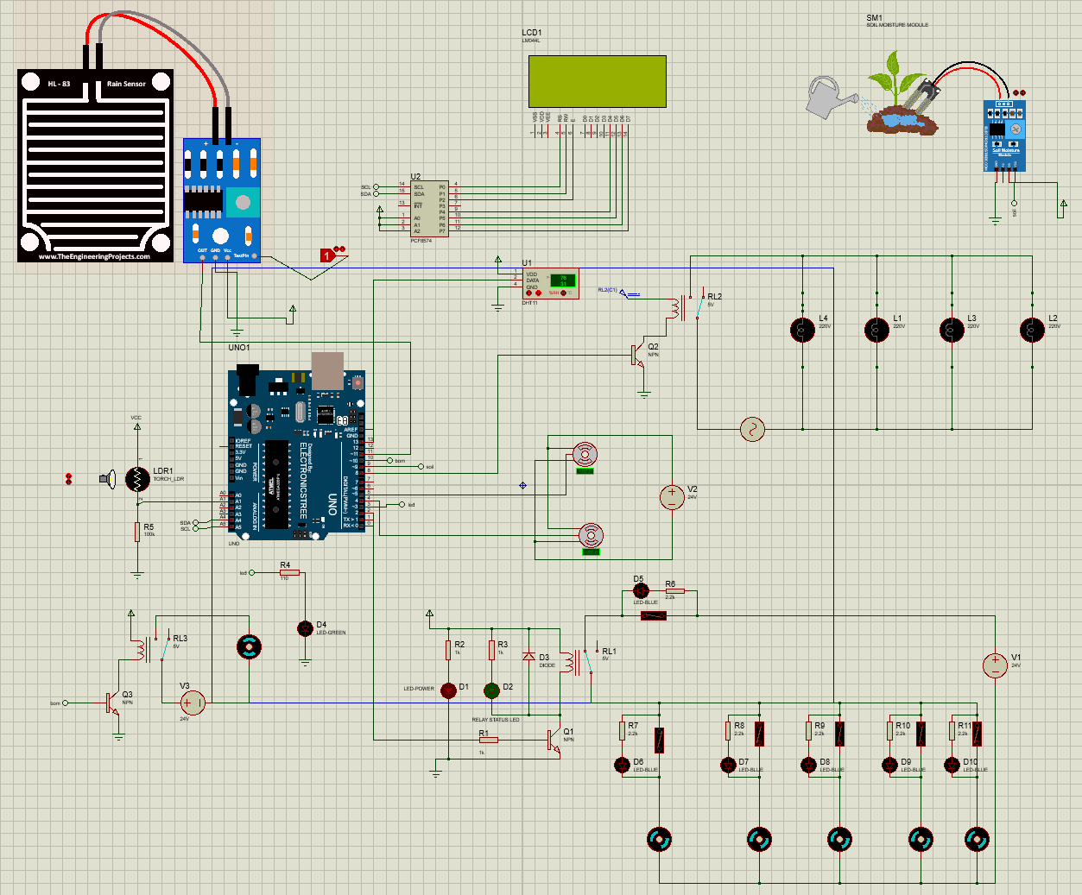
Figure 19: Overall circuit simulation in Proteus
The schematic implemented in Proteus 8.13 includes:
- Microcontroller: Arduino Uno
- Sensors:
  - DHT11 (Temp + Humidity)
  - LDR (Light)
  - Rain sensor module (Digital logic)
  - Soil moisture digital sensor
- Actuators:
  - Dual servo motors (curtain)
  - Fan + Heater Lamp
  - Water Pump
- Display:
  - LCD 20×4 via I2C
- Indicators:
  - LED for rain detection

B.2 Key Signal Flows
- Sensor Inputs:
  - LDR → Analog pin A1
  - DHT11 → Digital pin 13
  - Rain sensor → Digital pin 11
  - Soil moisture → Digital pin 9
- Actuator Controls:
  - Fan → Digital pin 2
  - Heater → Digital pin 8
  - Pump → Digital pin 10
  - Servos → Digital pins 4 & 5
  - Rain LED → Digital pin 3
- I2C LCD:
  - SDA → A4
  - SCL → A5
Note: All relays are driven via transistor drivers to protect the Arduino pins.

REFERENCES
[1] European Union Knowledge for Policy Platform, “Vietnam Country Climate and Development Report,” European Commission, Brussels, Belgium, 2022.
[2] Socialist Republic of Vietnam, “Vietnam National Communication to the United Nations Framework Convention on Climate Change (NC3),” Ministry of Natural Resources and Environment, Hanoi, Vietnam, 2019.
[3] “Tác động của biến đổi khí hậu đối với sản xuất nông nghiệp Việt Nam,” Kinh tế Môi trường, Vietnam, 2025.
[4] A. N. Rasyid, D. Hamdani, and I. Setiawan, “Rancang Bangun Smart Greenhouse Berbasis Arduino Uno,” *Amplitudo: Jurnal Ilmu dan Pembelajaran Fisika*, 2023.
[5] F. A. R. Mas, S. W. Suciyati, G. A. Pauzi, and J. Junaidi, “Smart Greenhouse on Monitoring of Soil Temperature and Humidity Control of Orchid Plants Using Internet of Things (IoT),” *Journal of Energy, Material, and Instrumentation Technology*, 2022.
[6] P. Wibowo, Z. Tharo, and A. F. Htg, “Design and Implementation of an Arduino-Based Smart Greenhouse Automation and Pest Repellent System,” in *Proc. 2nd Int. Conf. on Islamic Community Studies (ICICS)*, Universitas Pembangunan Panca Budi, Indonesia, 2023.
[7] A. Arsad, A. Bunyamin, and J. A. Manan, “Arduino-Based Low-Cost Greenhouse Monitoring System for Small-Scale Farmers,” in *Proc. 9th IEEE Int. Conf. on Engineering Education (ICEED)*, Kanazawa, Japan, 2017.
[8] Arduino AG, “Arduino Uno R3 Technical Documentation,” Arduino Documentation. [Online]. Available: https://docs.arduino.cc/hardware/uno-rev3.
[9] D-Robotics, “DHT11 Temperature and Humidity Sensor Datasheet,” Mouser Electronics. [Online]. Available: https://www.mouser.com/datasheet/2/758/DHT11-Technical-Data-Sheet-Translated-Version-1143054.pdf.
[10] J. Gutierrez, J. F. Villa-Medina, A. Nieto-Garibay, and M. A. Porta-Gandara, “Automated Irrigation System Using a Wireless Sensor Network and GPRS Module,” *IEEE Transactions on Instrumentation and Measurement*, vol. 63, no. 1, pp. 166–176, Jan. 2014.
[11] T. H. Nam and N. T. M. Phuong, “Research and Design of a Smart Greenhouse System Adapted to Climate Change in Vietnam,” *VNU Journal of Science: Computer Science and Communication Engineering*, vol. 36, no. 1, 2020.

